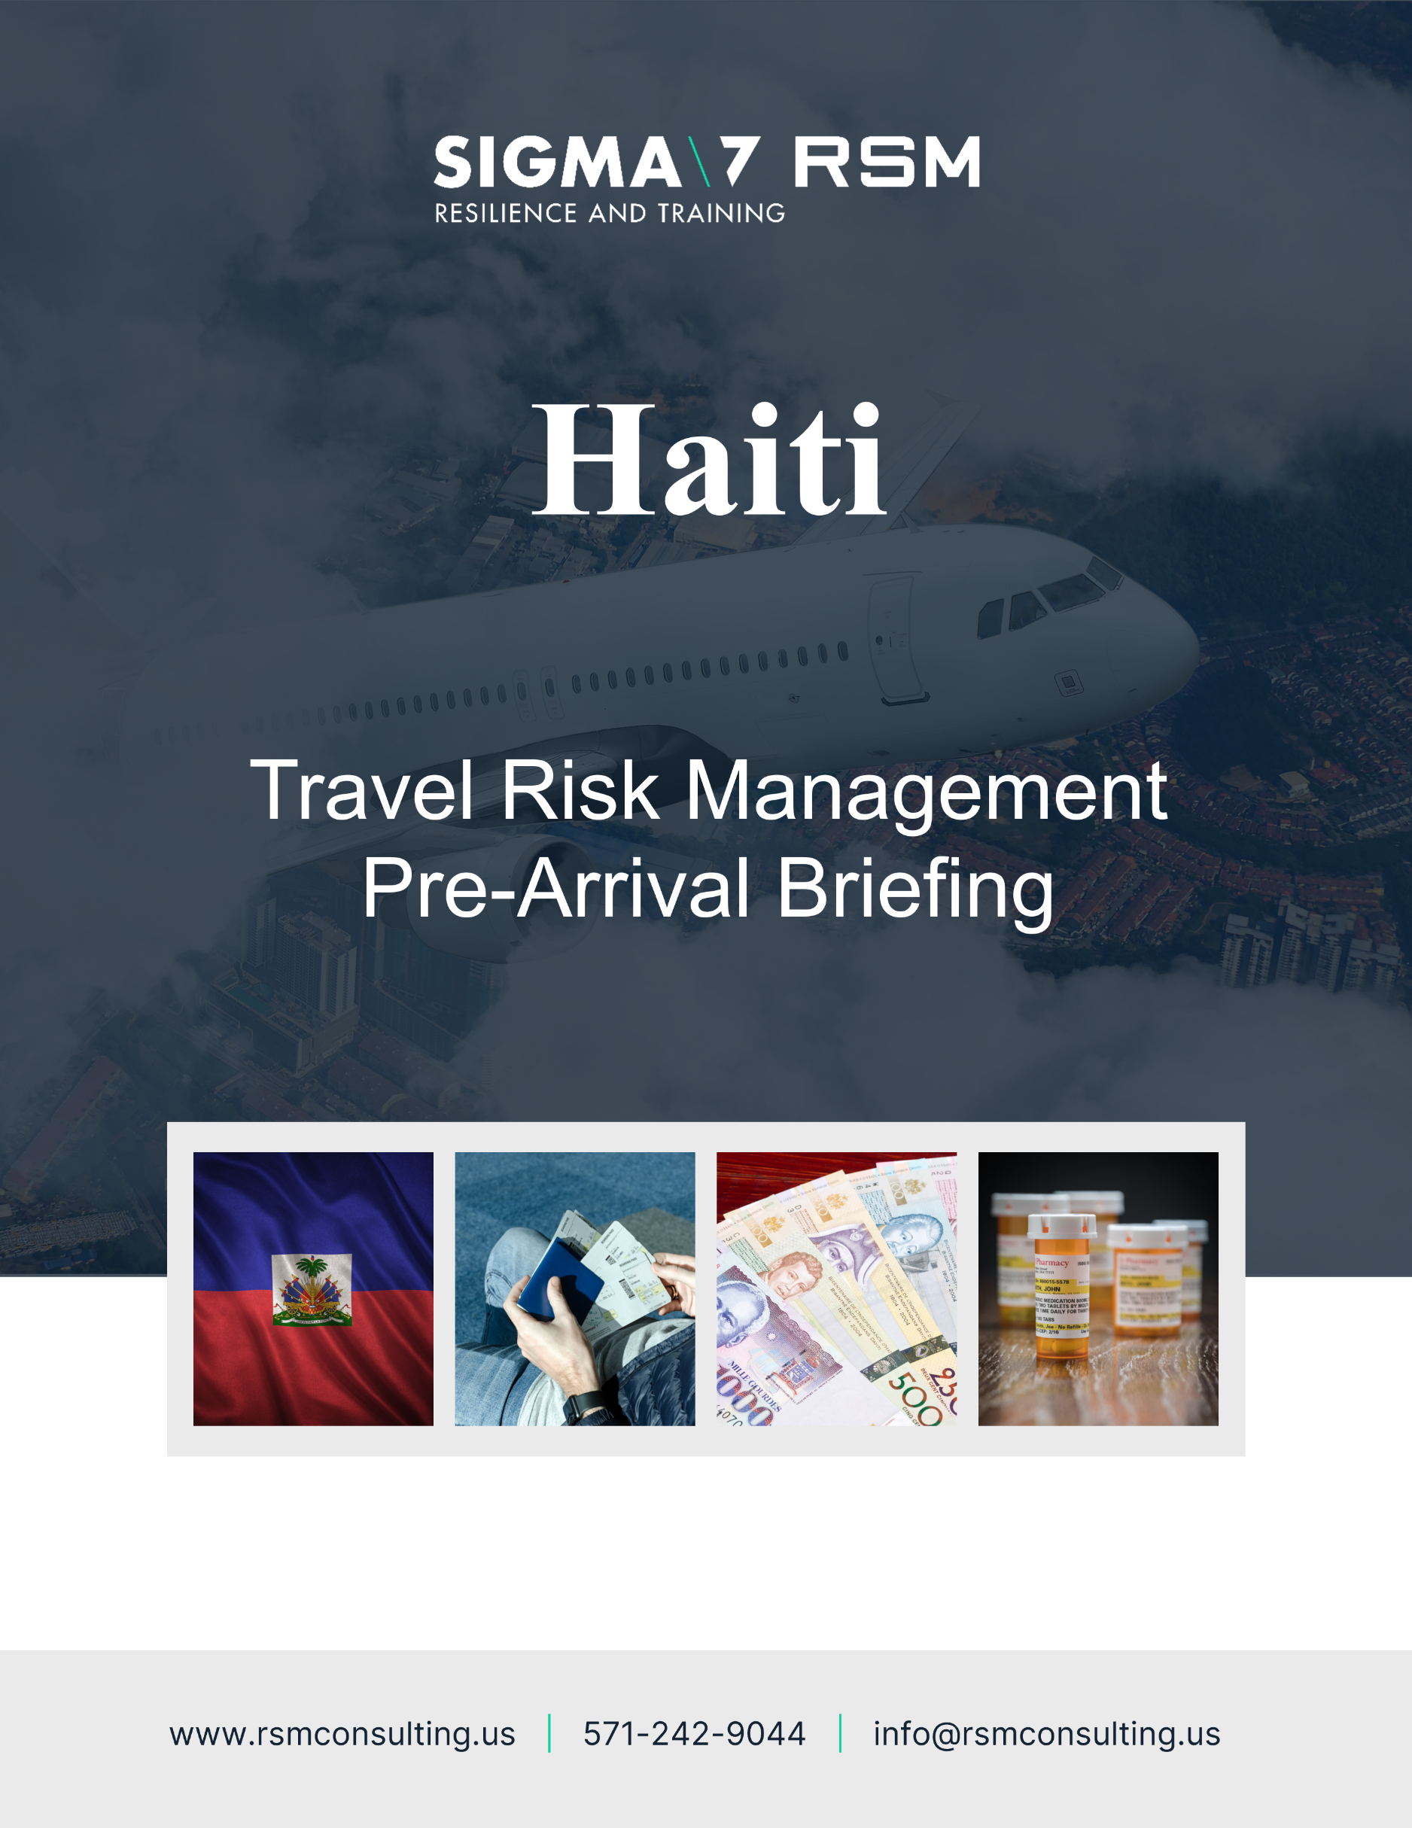
Tunisia

Welcome to Tunisia
The following Pre-Arrival Safety, Security and Cultural Briefing will be sent to international travelers 14 days ahead of their arrival or will be made available through standing [electronic] travel risk management systems. This briefing provides safety, security and cultural advice for this country, as well as useful points of contact. Travelers should proactively request information as needed.

The details of any ‘Meet and Greet’ personnel will be reconfirmed at least 24hrs ahead of your departure date by your host, including [ideally] the photograph, name and mobile phone number of the person collecting you. The traveler collection area or pick- up area will include a sign with “Project Name” for positive identification, if applicable.
It is the traveler’s responsibility to:
- Have an up-to-date copy of this briefing document in time for travel.
- Reach out to the in-country team for safety and security advice.
- Seek medical advice for the country to be visited [ahead of travel] through AIG portal: https://travelguard.secure.force.com/TravelAssistance/TGRegister?PL=AIGACCIDENTANDHEALTH and be fully fit to travel.
- Ensure you have up to date inoculations as well as the appropriate paperwork.
- Have the correct visas and travel documents.
- Attend the required briefings and training, well in advance of travel.
- Notify the appropriate stakeholders of the travel plan.
- Enroll in the Smart Traveler Enrollment Program (https://step.state.gov/step/) to receive Alerts and make it easier to locate you in an emergency.
- Conduct research on the country; its culture, social norms, history and safety and security issues.
- Have the correct prescription medicines [including spares].
- Have the ability to communicate during travel [mobile international roaming and VIOP] or purchase in-country SIM card and mobile phone or AIRALO apps.
  - Non (+1) phone numbers should be re-started on a daily basis.
- Keep emergency phone numbers registered on speed dial – and retained in a printed format.
- Notify personal bank or credit card company of the trip so your card is not deactivated.
- Carry printed copies of the passport and a digital photocopy and other documents [in case of loss].
- Carry essential equipment/supplies/medication within hand luggage/carry on.
- Have approx. $500 in emergency cash.
- Request a security and safety briefing before arrival.
- Notify the in-country team, and headquarters team, of any concerns or incidents immediately.
You should ensure that you take the time to prepare well in advance of your trip and seek advice and guidance in a timely manner.

Communications
The following points of contact will be associated with your visit. You are requested to save these on your phone and on your computer. A printed copy should be placed within your wallet or purse:

Main Point of Contact (Trip Coordinator)
Name: | Insert here
Email: | Insert here
Phone: | Insert here

Safety and Security Point of Contact (COP???)
Name: | Insert here
Email: | Insert here
Phone: | Insert here

Emergency Point of Contact
Name: | Insert here
Email: | Insert here
Phone: | Insert here


Embassy Emergency Point of Contact
Name: | U.S. Embassy Tunis. Les Berges du Lac, 1053
Email: | TunisACS@state.gov
Phone: | +(216) 71-107-00  Emergency after-hours telephone: +(216) 71-107-000, press 0 and ask for the duty officer
Phone: | The following number can be used to locate your nearest embassy: +1 202 501 4444
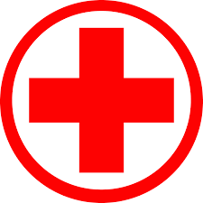
Local Medical Emergency Point of Contact
Name: | Insert here
Email: | Insert here
Phone: | Insert here

Insurance Details
Provider: | Insert here
Policy No: | Insert here
Phone: | Insert here

Please ensure you provide the following details to your trip coordinator:
- Your flight and hotel details.
- Your mobile phone number (please ensure it is switched to international roaming).
- Any VOIP details (such as WhatsApp and/or Signal).
- Any medicines or medical details we should be aware of.
- You next of kin details.
Registrations

You are recommended to register your trip with your embassy. For US citizens you should register under the Smart Traveler Enrollment Program (STEP) found at: https://step.state.gov/step/
Insurances

It is your responsibility to ensure all insurances (and copies of insurances) are complete before you travel. You should have electronic and printed copies of this information with you.

Information Sources

You are to coordinate with the Safety and Security Focal Point at least 10 days prior to your arrival for a verbal safety and security briefing. Information sites include some of the following websites:
- The US government (or your own) embassy website on safety and security topics for this country, including through: https://travel.state.gov/content/travel/en.html
- The CIA Fact Book on: https://www.cia.gov/library/publications/the-world-factbook/.
- The U.S Center for Disease Control [CDC] at http://wwwnc.cdc.gov/travel/ and the World Health Organization [WHO] at http://www.who.int/countries/en/ for health and vaccination information.
- Subscribing to alert services at AIG: https://travelguard.secure.force.com/TravelAssistance/TGRegister?PL=AIGACCIDENTANDHEALTH
- Federal Aviation Administration airport security information at www.FAA.gov.
- Hospital options: http://www.worldhospitalsearch.org.
- National Hurricane Center: http://www.nhc.noaa.gov/
- Visit the CDC page for the latest travel health information related to your travel https://Travel Health Information

Safety and Health Advice
You should ensure you are medically and dentally fit before you start your travels, carrying sufficient spare prescription medicines should your trip be unexpectedly extended. Emergency services are ill equipped to cope with a major disaster. Should a hurricane strike Tunisia, basic services including transport and communications are likely to be severely disrupted. Drainage is poor and flooding is common after rainfall. Road travel can be problematic and dangerous, long stretches of the route are isolated, and without mobile phone reception. Ensure you have all the correct vehicle documentation whenever you travel, MUST complete your entire journey during daylight as roads are often unlit and it is not uncommon after dark to encounter cars, trucks or motorcycles driving without lights.


Inoculations
The following inoculations are recommended for your trip:
- Ensure the following routine vaccines are current measles-mumps-rubella (MMR) vaccine, diphtheria-tetanus-pertussis vaccine, varicella (chickenpox) vaccine, polio vaccine, shingles vaccine and your yearly flu shot.
- Hepatitis A is contracted through contaminated food or water, regardless of where you are eating or staying. Unvaccinated travelers who are over 40 years old, are immunocompromised, or have chronic medical conditions planning to depart to a risk area in less than 2 weeks should get the initial dose of vaccine and at the same appointment receive immune globulin.
- Typhoid is contracted through contaminated food or water. Inoculations are recommended for most travelers, particularly if staying with friends or relatives, visiting smaller cities, rural areas, or eating street or other local food.
- Hepatitis B is contracted through sexual contact, contaminated needles, and blood products. It is recommended to have inoculations if you might have sex with a new partner, get a tattoo, piercing or have any medical procedures.
- Malaria is the number 1 cause of death, with 20% of deaths attributed to malaria. You will need to take prescription medicine before, during, and after your trip to prevent malaria (up to 10 days before travel). Consult your own doctor to help you decide which medicine is right for you, it is not recommended to self-prescribe anti-malarial medicines.
- Rabies is found in dogs, bats, and other mammals. Inoculations are recommended if you are traveling and involved in outdoor and other activities; including camping, hiking, biking, and adventure travel or caving. If you will be working with or around animals including veterinarians, wildlife professionals or researchers.
- Zika infection in a pregnant woman can cause serious birth defects; women who are pregnant should not travel to Tunisia. All travelers should strictly follow steps to prevent mosquito bites and sexual exposure to Zika virus during and after the trip.
- Cholera is a risk in parts of Tunisia. Vaccination is recommended for adults who are traveling to an area of active cholera transmission. Avoiding unsafe food and water can also prevent many cholera infections; although rare it can be server if contracted.

Medical
The following general medical advice is provided for this country:
- Ensure you carry on your person your medical insurance details and emergency contact details, and ensure a copy of these is logged with someone reliable in-country. Important Note: Unless it is a life-threatening situation you must contact your medical insurance provider who will inform you of which medical facility you should use.
- It is recommended to bring at least 1 months’ worth of additional prescription medicines with you to cover any loss or unexpected extension of deployment. A copy of the prescription should be brought and all medicines should be kept in the original packaging.
- Spare and additional prescription glasses or contact lenses and appropriate cleaning fluid, is recommended along with a copy of the prescription information should replacements be required.
- Normal medical facilities are very limited and offer a poor standard of care.
- A 2021 Report on HIV in adults gave the prevalence percentage of around 1.9% of the adult population compared to the prevalence percentage in Europe of around 0.2%.
- Insect-borne diseases including leishmaniasis and West Nile virus are common in Tunisia. To protect yourself from diseases, make sure your accommodation is insect-proof, use insect repellent and wear long, loose, light-coloured clothing.
- Waterborne, foodborne, and other infectious diseases are common. These include rabies and
- tuberculosis. To protect yourself from illness, drink boiled water or bottled water with sealed lids, avoid ice cubes, avoid uncooked and undercooked food, such as salads and avoid contact with dogs and other mammals.
- If an animal bites or scratches you, get medical help straight away.
- Swimming in fresh water may expose you to parasitic diseases, such as bilharzia (schistosomiasis).
- Get medical advice if you have a fever or stomach problems.

Natural Hazards
The following natural hazards are associated with this country:
- Throughout its history, Tunisia has suffered cyclones, hurricanes, tropical storms, torrential rains, floods and earthquakes.
- The hurricane season in Tunisia lasts from June to the end of November.
- Flash floods and landslides occur regularly.
- Tunisia is subject to periodic droughts and floods, made more severe by deforestation.
- It is recommended to monitor the media and other local sources such as the Global Disaster Alert and Coordination System
- During a natural disaster secure your passport in a safe, waterproof location and follow the advice of local authorities

Arrival Protocols
It is your responsibility to ensure you understand, and confirm, the arrival protocols for your trip, liaising with your in-country host. The following arrival protocols are to be applied:
- Confirm and share your travel schedule and internal country plans with XXXXX.
- Contact the trip coordinator appointed to manage your travel with questions.
- Ensure you receive the name, photograph and phone number of the person collecting you.
- Ensure you wait in the arrivals area upon arrival to be collected.
- If not met initially at the airport, do NOT leave the airport – ring the person collecting you – then ring your other in-country points of contact and remain inside the airport security area.
- When transiting in country notify your host of changes to your schedule.

Security Advice
The security situation in Tunisia is volatile. A state of emergency was declared in 2015 and is regularly extended. It remains in effect until further notice. The state of emergency grants authorities and security forces exceptional powers against threats of terrorism or organised crime. It allows actions such as preventative arrests, banning strikes or meetings and control of media.
UN peacekeepers have previously been deployed for years at a time to the country with little effect on long-term cyclical violence, as well as instability between natural disasters. Since the assassination of President Jovenel Moise in July 2021 gang control of the capital has grown to an estimated 60% percent; and in recent weeks the lawlessness that is currently pervasive throughout the country has led to criminal elements operating with impunity, and over 187 violent deaths within a two-week period alone (Feb 27 to March 9 of 2023). Crimes include violent muggings, some resulting in fatalities in areas popular with foreign residents. Kidnapping, already a high risk, has increased rapidly with 260 kidnappings reported since the start of 2023, abductions taking place at victims’ homes and in public spaces. Kidnappers target those who are perceived to be wealthy, and both Tunisiaans and foreign nationals have been victims of kidnapping. The violence has displaced hundreds of people in the capital, Port-au-Prince, and the central Artibonite region. With even farmers being displaced in an already food insecure country, crime and desperation are likely to surge in the short to medium term. Additionally, the Prime Minister is calling for the mobilization of Tunisia’s military to combat the violence, which could lead to an increase in risk to citizens and bystanders; Tunisia’s military has been disbanded in the past for participating in several coups.

Security Tips
The following security tips will help you have a safe and secure visit:
- Avoid demonstrations and crowds.
- Monitor local media for breaking events and be prepared to adjust your plans.
- Avoid staying overnight outside of the main cities and tourist locations.
- Obtain comprehensive medical insurance that includes medical evacuation coverage valid for Tunisia.
- The government prohibits the export of Tunisian currency, except in limited amounts. Up to TND 3,000 may be re-exchanged into foreign currency, with the original exchange receipt, upon departure from Tunisia. Visitors may only export up to TND 5,000 (or foreign currency equivalent; approximately $1,600 USD) if that amount was declared upon arrival. The Embassy frequently receives reports from U.S. citizens who have had their currency that exceeds these limits confiscated at the airport upon departure, even if they declare it.
- Terrorist attacks are an ongoing risk in Tunisia, including at tourist and religious sites. Local authorities have increased security. Be alert to possible threats.
- Instability in Libya and Algeria has resulted in greater volatility in southern Tunisia. There's a kidnapping risk in the border regions. If despite our advice you plan to travel to these areas, seek professional security advice.
- Civil unrest is common. Protests, demonstrations and strikes can occur with little or no warning and can become violent, especially on days of national significance and around Friday prayers. Avoid all protests and large gatherings. Follow the advice of local authorities.
- Petty crime, including pickpocketing and bag-snatching, occurs. Don't leave valuables in parked cars or unsecured in your hotel room.
- Women may be harassed on the street. Take care when travelling alone or at night.
- If you need to exchange money, only do so at banks or authorized exchange houses. Whenever possible, conduct banking transactions electronically. If you need to visit financial institutions or ATMs, choose a branch located inside a shopping mall, preferably in the morning, and withdraw small amounts of money.
- Carry a small, rubber doorstop to help secure your hotel door at night.
- Carry a very bright handheld flashlight in case of emergencies.
- Ensure you have a charger and converter for your laptop and phone.
- Avoid walking alone at night.
- Do not accept lifts with strangers or give strangers lifts.
- Protect your information and be careful what you say in public.
- Do not take photographs of government installations or sensitive locations.
- Track the security situation, avoid areas prone to crime and alert your manager if risks increase.
- Ensure you separate your money when walking in the street with the larger amount being in a less obvious location. Always have something to give a robber.
- Always use the lock on your hotel door, as well as the peephole before opening the door.
- Select a meeting point for your group away from the hotel’s fire muster point.
- It is recommended to avoid travelling at night anywhere in the country including major cities.
- Travel out of cities is possible with most main routes in and between towns and cities in good or reasonable condition, but there are exceptions, especially in remote rural areas where some roads can only be travelled in 4x4 vehicles and with great care. Complete all travel during daylight hours.
  - Perform a vehicle inspection:
    - Spare tire
    - Oil levels
    - Extra Fuel
    - Water
    - Functioning lights and blinkers
    - Medical Kit – located in office
  - Caution is recommended on the road between Tunisia and the Dominican Republic. There have been incidents of armed robberies of foreign nationals at Dominican side of the border by criminals dressed as police officers. If you cross the border by land, be prepared for long queues at the 4 crossing points.
  - Make sure you have all the correct vehicle documentation. Long stretches of the route are isolated, and without mobile phone reception. MUST complete your entire journey during daylight.
  - The use of Route Nationale 1 is not recommended, due to insecurity involving, daily and sometimes violent, demonstrations.
- The political situation in Tunisia is unpredictable and chaotic, besides security issues with regards to the ongoing lawlessness and potential military interventions it is ALWAYS important to avoid political rallies, demonstrations, and crowds. Demonstrations may occur with little warning and can turn violent. While most common in Port au Prince, other main cities, including border crossings, they can occur anywhere. Demonstrations may often be accompanied by improvised roadblocks; curfews and new security regulations can be announced at short notice. You should monitor local news and follow the advice of the local authorities, while leveraging access to external consulting firms and risk monitoring resources.
Transport Security Tips
- Exercise caution when using public transportation, due to safety and security concerns. Trains, buses, and taxi minibuses (known as louages) may be overcrowded, have unsafe driving practices, poor maintenance, and increased likelihood of criminal activity.
- Bolt and Uber are two apps commonly used by tourists to travel safely, as they offer GPS tracking. However, there are also other options for booking taxi rides, such as https://www.taximami.com/.
- Driving in Tunisia can be dangerous. Visitors should avoid driving after dark outside Tunis or major resort areas or on country roads.
- Drivers often fail to obey the rules of the road, even in the presence of police. Traffic signs and signals are often ignored, and drivers sometimes drive vehicles on the wrong side of the road or the wrong direction on a one-way street.


Information Security
The following security tips will help you have a safe and secure visit:
- Do not leave sensitive documents unattended or on public display.
- Do not enter the country with potentially sensitive information on your electronic devices.
- Use a VPN on all devices where possible (Proton VPN).
- Never discuss or share itineraries or plans with non-designated security personnel or on any social media platforms.


Calendar Risk Events
The following calendar events could raise security risks for visitors:
- Jan 01st New Year's Day
- Jan 17th Inauguration of Jovenel Moïse
- Feb 28th Carnival & Shrove Tuesday
- Apr 14th Good Friday
- Apr 16th Easter Sunday
- May 01st Agriculture and Labor Day
- May 18th Flag Day & University Day
- Jun 15th Corpus Christi
- Aug 15th Assumption of Mary
- Oct 17th Dessalines Day
- Nov 01st All Saints' Day
- Nov 02nd All Souls' Day
- Nov 18th Vertières Day
- Dec 25th Christmas Day


Exercise increased caution in Tunisia due to terrorism. Some areas have increased risk.
Do not travel to;
- Within 16 km of the Algerian border (except for the following towns where we advise exercise a high degree of caution: Ain Draham, Chebika, Mides, Tabarka, Tamerza),
- Within 30 km of the Libyan border, specially to areas such as Ras Jedir and Dehiba along with the cities of Ben Guerdan and Medenine.
- The mountain ranges and surrounding forests of: Mount Chaambi National Park, Mount Mghila in Kasserine governorate due to terrorism (which extends to the governorate of Sidi Bouzid), Mount Sammama, Mount Orbata area in the Gafsa governorate, Mount Salloum and the cordoned off military zone south of the town of Remada in the governorate of Tataouine.
Reconsider to travel to the following locations due to the presence of a military zone, the risk of terrorism, and limited mobile coverage:
• The Delegation of Remada
• Mount Orbata.
This map shows which areas should be avoided: https://www.smartraveller.gov.au/sites/default/files/2024-09/tunisia_240912.pdf

Cultural Advice
Be respectful of the local culture in terms of how you dress and interact with others. Ensure you understand, and be courteous of, religious and gender differences, as well as the rules for social contact. The following cultural advice is provided for this country:
- Targeted Population Considerations: Homosexuality is legal but the attitudes of many Tunisiaans to gay, lesbian, bisexual, transgender and intersex people is hostile.
- Religious Considerations: Roman Catholicism is the official religion of Tunisia, but voodoo may be considered the country's national religion. Many Tunisiaans believe in and practice at least some aspects of voodoo, with most voodooists believe that their religion can coexist with Catholicism.
- Gender Equality Considerations: Political instability, chronic poverty, and crime all contribute to a high prevalence of gender-based violence and discrimination against Tunisiaan women and girls. Tunisia’s Constitution does protect women from workplace discrimination as well as physical and sexual abuse and guarantees the right to political participation; but often women routinely face exclusion and harassment in public and private life. Tunisia has an active women’s movement, despite this, women face higher rates of unemployment, are more likely to suffer poor health outcomes, and are less likely to own land or hold political office than men. Women seeking political office face considerable obstacles, including patriarchal attitudes toward leadership, lack of financial support, and threats of violence and intimidation.
- Social Norms: Titles are very important, and it is best to address people directly by using their professional title or Mr., Mrs., or Miss, followed by the surname. It is advisable, but not required, to have one side of your business card translated into French.
- Local Laws: Don’t become involved with illegal drugs of any kind ensure you pack all luggage yourself and don’t be tempted to carry items through customs for anyone else. If you are caught in possession of drugs or suspected of drug trafficking, arrest followed by jail for weeks or months before appearing before a magistrate are possible. Prison conditions in Tunisia are very poor.

Administrative Advice
The following advice is provided to assist you with a more pleasant and productive visit:
- Cash and ATMs: Avoid using banks or withdrawing money at cash points unless absolutely necessary and don’t carry large sums of money. Always be aware of your surroundings and who might be watching you. If necessary, make withdrawals from cash machines in supermarkets with security guards.
- Emergency Cash: In the event that you run out of cash and your credit cards are not working then you can have a family member wire monies via Western Union to a branch near where you are staying, noting that wires over $7,500 are often delayed as they are subject to US Government scrutiny: https://www.westernunion.com/us/en/home.html or Money Gram: https://secure.moneygram.com
- Food and Water: Tap water is not potable and you should ensure you have sufficient water for your own use for at least three days if supplies run short. All perishable purchases should be carefully washed before consumption. The consumption of street food is not recommended. Large cities have restaurants which can be visited under advisement from local contacts as to their quality and hygiene.
- Essential Items: Prescription medicines including anti-malarial
  - Non-prescription medicines to cover common ailments including stomach upsets, flu and any personal medical concerns.
  - Clothing to protect against extremes of heat and cold.
  - First aid kits with the skills and knowledge to use them.
  - Copies (and digital) of all official documents from passports, visas, letters of introduction and insurance documents.
- Communications: A sound plan should be established to address primary secondary and tertiary options for communication. Agreeing check in times and frequency with trusted individuals and agreeing when those individuals when they should alert authorities should you not make contact. Testing communication plans before departure and during your visit.
- Climate and Dress: Tunisia has a generally hot and humid tropical climate. The north wind brings fog and drizzle, which interrupt Tunisia's dry season from November to January. Northeast trade winds bring rains during the wet season. Port-au-Prince receives an average annual rainfall of 1,370 mm (53.9 in). There are two rainy seasons, April through to June and October through to November. Clothing should be able to meet the demands of the heat and several loose layers to address the areas with cooler nights. Stout waterproof and breathable outerwear and footwear is recommended during rainy seasons due to flooding and insecure ground in more remote areas.
- Sanitary Products: Availability is unknown at the moment and therefore it is advisable to ensure you bring additional supplies of your own preferred brands.
- Local Phones and SimCards: Mobile telephones are widely used, and roaming is available for some service providers (Digicel, Natcom). Signal reception varies but is generally acceptable around Port-au-Prince. You can buy local SIM cards and prepaid cards in the main towns or via the AIRALO app.
- The Internet: A number of providers are in country providing satellite options including iDirect, UHP, Newtec and Comtec. As of 22 March 2023 SpaceX’s Starlink announced that its service is now available in Tunisia.
- Visa Requirements:
  - A tourist visa is not required for stays under 90 days.
  - For U.S. passport holders, a visa is not necessary for stays up to 90 days.
  - A residence permit is needed for stays longer than 90 days. The residence permit can be obtained from the central police station of the district of residence in Tunisia.
  - U.S. citizens born in the Middle East or with Arabic names have experienced delays in clearing immigration upon arrival in Tunisia.
  - The Government of Tunisia expects all U.S. citizens of Tunisian origin and who are dual American-Tunisian citizens to enter and exit Tunisia on their Tunisian passports. If a Tunisian-American succeeds in entering using a U.S. passport, he or she will still have to present a valid Tunisian passport to exit the country.

Meet and Greet
You will be met at the airport on arrival by a member of the team. Please ensure you have a printed copy of the details of the person meeting you. If the person is not at arrivals, then do NOT leave the safety of the airport, ring your ‘Meet and Greet’ and then move through the points of contact you have been provided. If a last-minute change occurs then this will be emailed to you. The following person will be meeting you at the airport:
Name: | Insert here
Email: | Insert here
Phone: | Insert here
Photograph
Include photo if possible below

